**Themes**

In this document, I’m going to go over different kinds of themes that can be suitable to the 2D Platforming game idea our group has agreed on. My focus is to research a variety of themes that would be both appropriate and scopable for our project.

*Theme #1*

**Beach**

Beach levels are a kind of unique beast that you can typically find in most across-the-board kinds of platformers. For example, in the Super Mario series there are beach levels in several different games because of how different, and how easy it is to emulate a beach. There isn’t many gaps for the player to fill when it comes to a beach, for example, if a person were to see a blurry image where there’s blue water, pale yellow on the bottom and a bluish hue filling the rest, they can more than likely distinguish what it is without putting much thought into it.

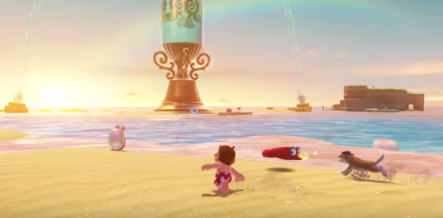

->

I feel that a beach theme would very simple to emulate, and with it being beach themed there are a variety of ways we can theme the context of the game. For example, the objects being slingshotted could be beach balls, and the conflict (the enemies) could be sharks. Or the roles could even switch, where the player plays as a shark that throws rocks at humans on the beach, etc.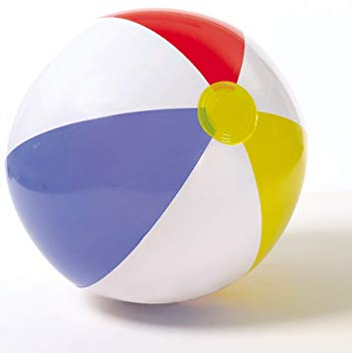

In conclusion, the benefits of a beach themed game is that it is very colourful to the eye, simple to pull off, and there’s a variety of things that can be done with it in terms of the art. I feel that the primary challenge we might face when it comes to developing this idea further is that if we want to have water as a focus of our level. We’ll need to start thinking further about whether we want the water to be animated or not, which if so may add extra pressure on the programming side of things. More challenges could be the animation of wildlife-- for example, birds that occasionally fly around the top of the screen.

*Theme #2*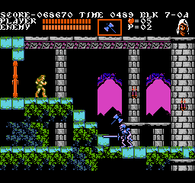

**Medieval**

This idea would definitely be more on the gothic side of things. A much darker, and a little more serious. My initial idea for this is that the player plays as a warrior that throws axes/hatchets at oncoming enemy soldiers. One really good example of games with this gothic/medieval theme is the Castlevania series (which is a 2D Platformer that we are aiming to make).

Enemies can range from generic fantasy enemies like Skeletons, Zombies, Ghosts, and Bats. However, I feel that immediately this idea is going to be much harder to pull of in comparison to the beach idea. A lot more thought is going to be needed to create an immersive experience for the player. For example, in comparison to a beach where a person could instantly distinguish that kind of level, depending on execution there will be a certain level of cognitive demand from the player.

However, a way we could pull this off in a more simple way could be a more dungeonesque design.

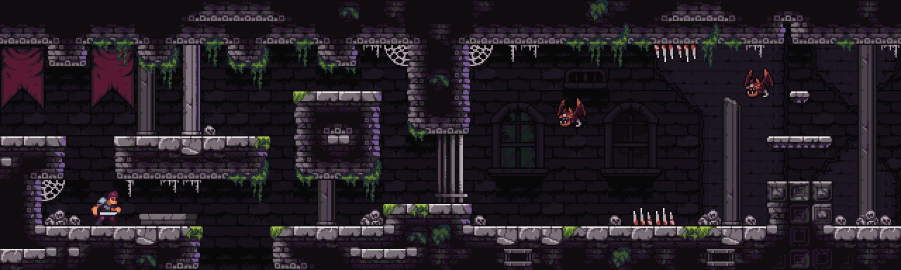

A dungeon is relatively easier to emulate; as they often contain stone tiles, bones of dead enemies *and* the kind of enemies (previously mentioned) would be easier to associate with this theme, which leaves less sensory gaps for the player to fill therefore makes immersion easier in the process. The player plays as the hero; either a rugged knight or a warrior that enters the dungeon in search for the legendary loot.

To conclude the summary of this theme, I feel it can carry a far more serious dungeon-crawler vibe. I think with this idea I can propose an interesting feature in regards to the lighting of the level which is this: there are torches all around the level that only light a certain radius of the map per torch; creating patches of darkness that the player doesn’t know about. To further idea even more, the player can presented with a barebones stage with few torches, and they can switch the slingshot ammo to be a torch which the player can launch, and that torch can also light a radius of where it lands. However, this begs the question of whether this is a *scopable* idea; as something like this can be technically challenging to implement.

*Theme #3*

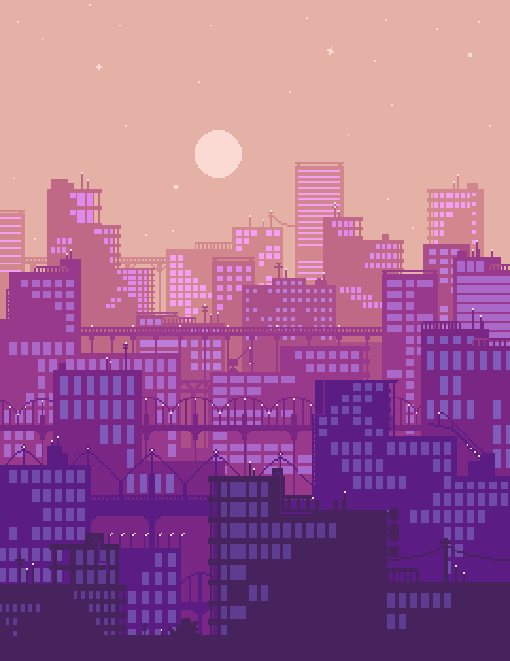

**Cityscape**

This theme idea is definitely something that can be used as a base, and the detail of the level can change easily. For example, the time of day that we choose to have for the level can affect how busy the city is. If the player were to slingshot their object, and the object falls we would need to consider whether or not if we’re going to render the bottom of the level and what it would look like. For example, would we see the object fall into a slow moving New York gridlock? Or would there perhaps it’s night time, and there are fewer cars but are always moving? There are lots of different things to consider when making it.

Animation is also a thing to consider, because for something like a cityscape it’s probably a good idea to have a lot of things moving to immerse the player. In terms of being a sensory information, I don’t believe the player will need to fill many gaps to understand the environment that they’re playing in. However, the layout of the level is definitely something to consider, as well as the enemies and as well as the protagonist of the game.

An idea for a level layout could be a construction site; where the player is playing as a builder, and the enemies are wild, rabbid seagulls. The builder can be trying to progress through a level filled with construction equipment and scaffolding all whilst avoiding the seagulls attacks. An extra layer of detail is that the level could be interactable. If the player manages to successfully launch their character into a crane, for example, then they can take over it until the crane’s fuel meter runs out. The crane could swing (attack) and scare off some of the seagulls that are trying to attack the player. In the crane the player is invulnerable to the enemies attacks, and can only use it until, as previously mentioned, the fuel meter runs out. A fuel meter will be consumed over a certain amount of time, and once it runs out, the player can no longer control the crane. This will mean that the player cannot repeatedly jump into the crane and attack the seagulls. However, there are multiple issues that need to be identified with this idea. The first is the animation. Not only will the seagulls need to be moving targets that home in on the player’s location, but they will also require a flying animation. In addition, if the crane idea does also happen, the crane will also need to be animated for moving/attacking. An extra component to this, the fuel component, will also need to be an entirely different thing on its own; draining over time and also requiring an animated bar.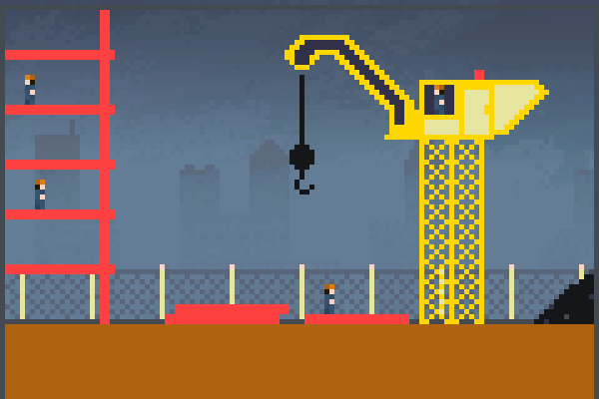

*Theme #4*

**Space**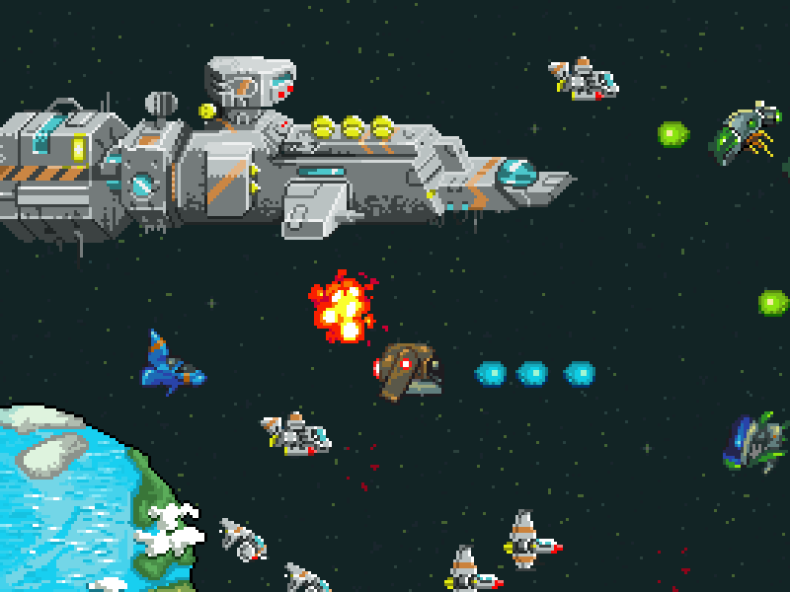

Space is also another common theme amongst the 2D platformer genre, and is actual a very popular kind of level for a variety of different game genres. The reason for this being that it is a very easy kind of level to emulate; there is plenty of ways that it has been depicted in media. I feel like this is the idea that we can do the most with, but might also be the most creatively heavy theme among them all.

First, the main thing to consider with a space theme is what is the context of our level. Who/what is the player, who are the enemies, and what is the main objective of the level. And initially an idea I had would be that the player plays as a spacecraft that is trying to navigate through an asteroid field. Where that might be an interesting idea, it doesn’t quite fit in with the slingshot mechanic we’re trying to go for.

Another idea could be that the player plays as an astronaut on the moon that is trying to avoid strange alien lifeforms. Of course, this idea also begs the question, in terms of immersion, how that would affect the core gameplay. With the player being on the moon we would need to account for gravity. The player couldn’t slingshot and land; there would need to be delay and a lack of gravity to account for. This could actually add an interesting gameplay feature where the player character also bounces around a little before landing. This, however, could make the platforming a little more difficult and/or rage inducing, but when going for a space-type of level it’s going to be important to account for these kinds of things.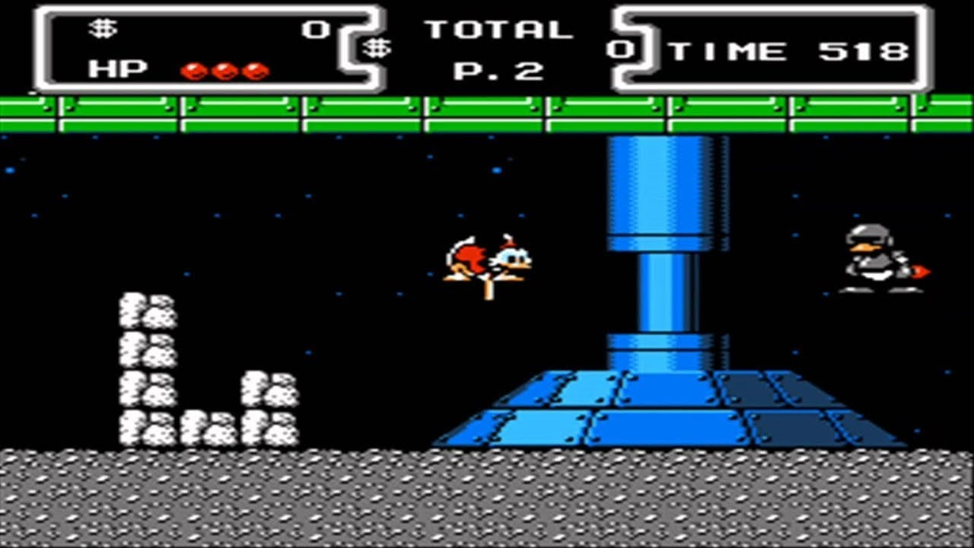

In terms of the challenges that we would face with this idea, I’m unsure whether animation is going to be something that would be a top priority issue. Like mentioned before, our main challenge is going to be flexing the gameplay to be much more based on the gravity (or lack of) to fit in with the theme of the map. If we were to animate it, I think that the background would be the main thing to be animated which might not be as much of an issue as some of the other animating ideas/challenges I’ve presented in the previous themes. This would mainly be stars twinkling, and maybe even having the atmosphere of the Earth ripple a little bit.